510 SW Fifth Avenue Suite 300
Portland, OR 97217
503-706-4204
info@advancedtechcomm.com www.advancedtechcomm.com
https://www.flickr.com/photos/advancedtechnologycommunications/albums
https://vimeo.com/advancedtekcomm.com

Statement of Qualifications – January 2020

Founded in 2015, ATC leverages the latest in innovative communications technology to our three main areas of practice - aerial imaging and data collection, communications/public involvement, and construction diversity. Our extensive experience and track record of success in all three disciplines creates cost effective, world class results for public and private organizations and businesses.

UAV Drone/Services

Located in Portland, Oregon Advanced Technology Communications LLC (ATC) provides aerial videography, photography, data collection and systems design services to public agencies and private clients in the Pacific Northwest, West Africa and Central America. Main areas of focus include public affairs and communications, construction and development, ports and harbors, planning and environment and real estate, and security. ATC is bilingual in Spanish and English.

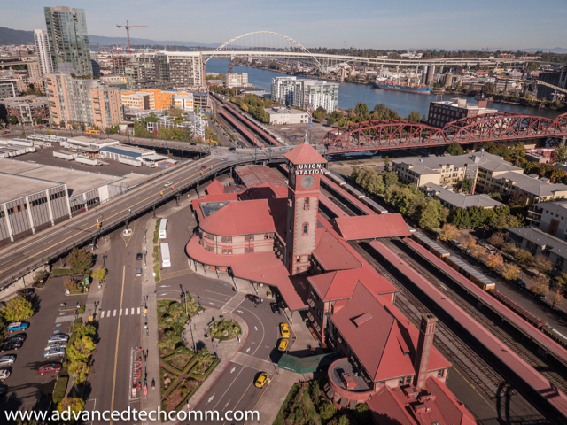
CEO John Jackley holds a Part 107 FAA Remote Pilot Certificate with a small Unmanned Aircraft System (sUAS) rating (scored 98% on the Part 107 test); an FAA Safety Certificate (100% on test); and a Remote Pilot 101 Certificate from MZero Aviation (Ocala, FL).

ATC is a State of Oregon certified Emerging Small Business (ESB) and is FAA certified for drone operations in the United States, the State of North Carolina (requires a separate permit), the Republic of Panama and the Republic of Ghana. ATC is also one of the few drone companies in Oregon to receive FAA authorization for nighttime flight operations. ATC is authorized to receive automated authorization in controlled airspace around the country through the FAA LAANC system (Low Altitude Authorization and Notification

Capability).

Mr. John Jackley founded ATC after serving as Director of Communications and Social Equity at the Portland Development Commission (now Prosper Portland) from 2006 to 2016, as head of the Neighborhood Division urban renewal areas from 2012-2015. He previously served as Executive Officer at the Oregon Department of Transportation with a $455 million biennial local government construction portfolio, including the $100 million Connect Oregon program; and as ODOT Public Affairs Manager. He also served as a senior advisor on communications, policy and security in the U.S. House of Representatives and the Oregon Senate, and was an elected City Councilor in West Linn, Oregon. He brings this extensive experience and success in communicating about public infrastructure and commercial development to the drone industry.

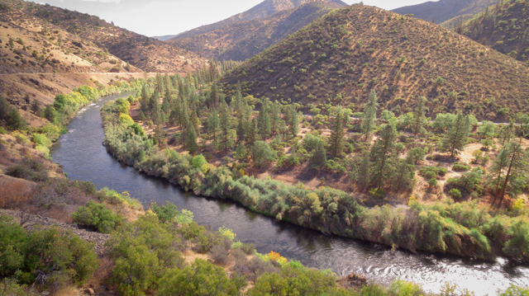

Lower Klamath River Dam – Dam Decommissioning Proposal Team

At PDC he led the agency into the drone age, directing Unmanned Aerial Vehicle technology on construction and demolition projects, establishing procedures for UAVs in construction, and producing training and educational materials.

His full resume can be found at https://www.linkedin.com/in/john-jackley-bba5b58/.

Selected projects include:
- Aerial video, photography, mapping, environmental and virtual reality tours for the Willamette Water Supply Program – three year, 92 project contract for drone services for 60 miles of water pipeline construction and water treatment plants (2019-2021).
- Aerial video, photography and virtual reality tours of multiple highway and transit facilities for the Hillsboro, Oregon Transportation Department (2019-ongoing).
- Construction progress documentation- aerial and ground video, photography and time-lapse, Joint Water Treatment Plant, City of Hillsboro (2018-2020 – site location is in Forest Grove, OR).
- Design and deployment of a UAV/drone aircraft system for the Ghana Ports and Harbours Authority at the ports of Tema and Takoradi; and aerial videography and photography at the Port of Tema, Republic of Ghana. (2017-2020).
- Raimore Construction, transit center and highway aerial photography and video, 2019.
- Champion Homes and Dweller LLC, aerial and ground video and photography, Matterport scan for Portland-based ADU startup (2018-2020).
- Drone real estate tours, Windemere Realty, 2019-2020.
- Drone training for Portland region Latino professionals, Prosper Portland grant, 2019-2020.
- Drone training – Togo Community of Oregon, 2019-2020.
- Drone training – African Union students, 2019.
- Portland State Sustainability Center, 2019.
- Videography, photography and time-lapse imaging for the My People’s Market at the Rose Quarter (June 2018).
- Aerial photography, videography and mapping for the Wapato site, formerly a Multnomah County corrections site on West Hayden Island now in private ownership and under consideration as a homeless housing facility (June 2018-ongoing)
- Aerial photography, videography and mapping for the upcoming Navigation Center of the Oregon Harbor of Hope, a nonprofit dedicated to solving homelessness (May 2018-ongoing).
- Aerial videography and photography for Prosper Portland for the SE Clinton Street Triangle and the ODOT Blocks in the Central Eastside (2018).
- Aerial videography and photography for Lara Media Services web page (2018).
- Aerial videography and photography of the Natural Grocers development in NE Portland (2018).
- Aerial videography and photography of construction and infrastructure projects for the Northwest Examiner, Portland, Oregon (2017-18).
- Interior and exterior aerial videography for the grand opening of the Karl Miller Center at Portland State University (2017).
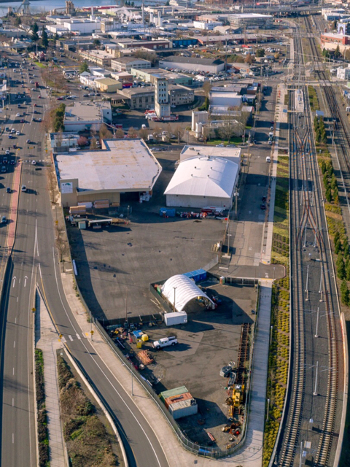
- Interior drone tours of the venues at the Arlene Schnitzer Concert Hall and the Keller Auditorium for Portland 5’ Performance Art Venues (2018).
- Aerial videography and photography for the Broadway Corridor Plan project for Prosper Portland (2017-18).
- Aerial videography and photography for the El Grito celebration (Mexican Independence Day, 2017).
- Aerial videography and photography for a proposal team for the Lower Klamath River dam decommissioning project (Hornbrook, CA), 2017.
- Aerial videography and photography for SEADCO Farms, Shai Hills Region, Ghana (2017).
- Aerial videography and photography for various clients in the Republic of Panama – Burica Surf Lodge, Mazatlan Corporation, Finca de los Rios vacation resort,

and Panama Virtual Business S.A. (2016-present).
- Aerial videography and photography for

real estate in Fenwick Island, DE.

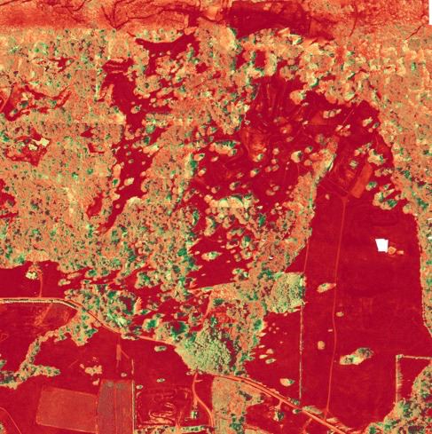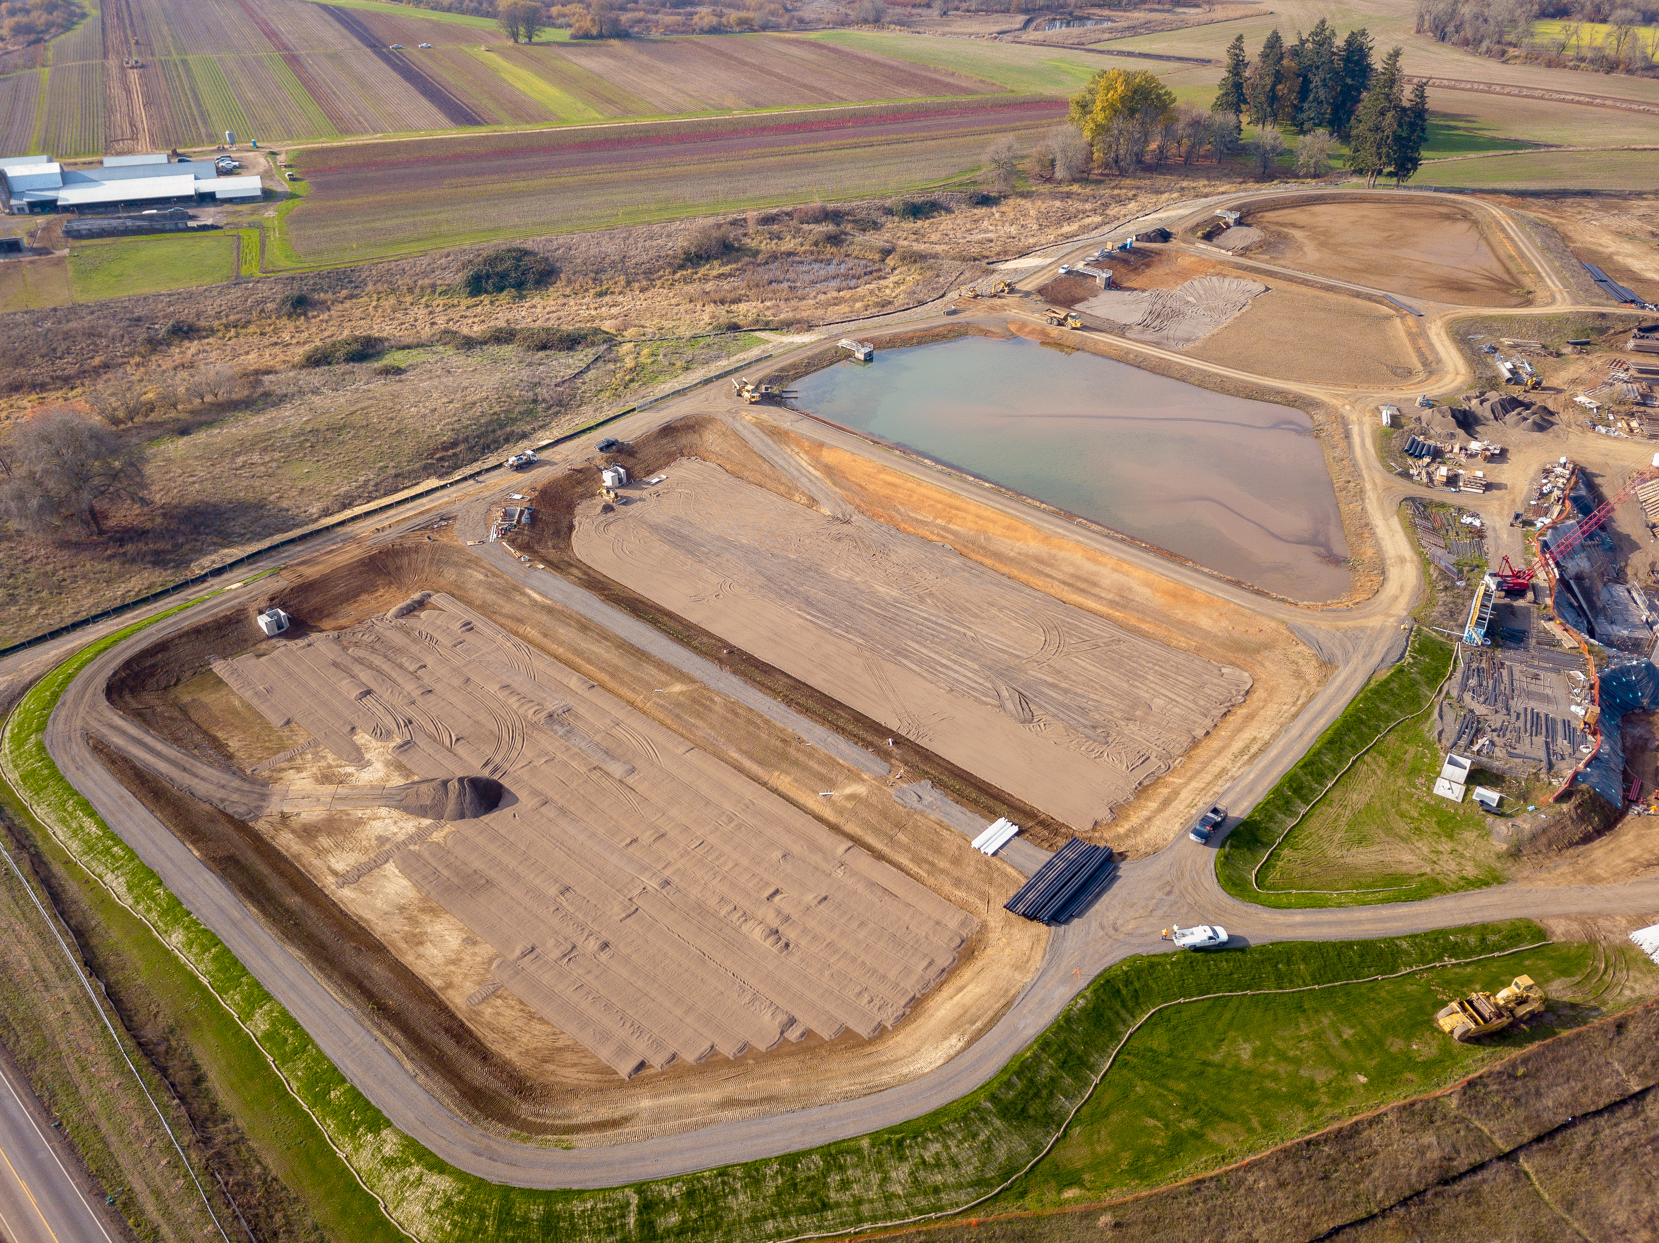

Building a Diverse Drone Tech Workspace

When ATC founder John Jackley served as Communications and Social Equity Director of the Portland Development Commission, the agency won national recognition for its record-setting utilization of women and minority contractors on PDC-funded construction projects. He has carried this passion for diversity and inclusion over to ATC’s work as a UAV/drone service provider in the United States and overseas. In addition to having one of the most diverse teams in the UAV/drone industry, ATC is committed to educating and training underrepresented communities, especially women and young people of color, in this technology that serves as a gateway to a wider STEM education (Science, Technology, Engineering and Mathematics).

ATC has two significant inclusivity projects underway – 1) to provide drone training to Latinos in the metro region, a program that Mr. Jackley will teach in Spanish and English in partnership with the HispanicPros organization; and the upcoming Technology in Construction Conference in partnership with HispanicPros. Currently, ATC conducts business in English, Spanish, Portuguese and Twi (a major language in Ghana).

- ATC is a State of Oregon Certified Emerging Small Business (ESB).
- ATC’s project manager is a Native Hawaiian/Filipina female, Beaverton.
- Project space rental – Kaplan Building, downtown Portland.
- Flight tech – deaf white male, Portland and Astoria.
- Designer – Latino MBE/DBE firm + another Latino employee of the firm, Portland.
- Legal counsel – African American owned firm (former legal counselor to Governor of Oregon), Portland.
- ATC’s CFO/COO is Ghanaian-American from Washington County.
- When projects require additional pilots, ATC contracts with a female pilot, an African-American pilot, and a disable Iraq war veteran pilot.

ATC‘s Visual Observers are people of color or a woman, or both, to continue this commitment to expanding opportunities for inclusion in the drone technology space in the Northwest.
Aerial Data Collection

Safety
ATC CEO John Jackley spent seventeen years in commercial and infrastructure construction, where a culture of safety is instilled daily and is paramount to all other considerations. This commitment to safety is at the heart of the firm.

The FAA adopted the Small Unmanned Aircraft Rule (Part 107) effective August 2016. The rule has many safety requirements, including a weight limit of up to 55 lbs., a prohibition of flying over people, daylight flying and visual line of sight only, and a ceiling of 400 feet above ground level unless flying within 400 feet of a structure. ATC rigorously observes these requirements and has incorporated them into a comprehensive Operations Manual, preflight checklists and flight procedures. ATC follows all FAA and sUAS Maintenance and Inspection Best Practices (AC 107-2).

While the FAA requirements are a sound foundation, ATC goes beyond them to create an additional margin of safety. When needed, we have a trained visual observer in addition to the pilot. We also employ geofencing, which uses the aircraft's onboard GPS sensors to restrict and control the aircraft to certain areas; and hand-held radios to communicate with our team and with Air Traffic Control if needed. ATC also uses a series of apps to verify on-site the weather, current and future satellite coverage for GIS, electromagnetic interference and levels of geomagnetic radiation (Kp factor).

For flying in crowded spaces we use drones that have sonar-based object avoidance technology and geo-fencing. The Inspire 1, for example, has sonar sensors and cameras for obstacle avoidance, and the Mavic Pro, Mavic Pro 2 and Phantom 4 Pro also have a combination of sonar and cameras as part of their Vision Positioning System. ATC owns, maintains and certifies for flight readiness all of its drones.

In addition, ATC also functions as a general contractor for drone services with trusted subs in the areas of LIDAR, cinematography, 3D scanning, and specialized environmental studies.

ATC aircraft have built-in Return to Home technology that prevent the UAV/drone from flying further away than battery life to return to the launch point. And if for any reason the radio control signal is interrupted, the aircraft will return to the GPS way point from which it was launched.

In addition to proper awareness of the satellite signals and GPS locations, weather is another extremely important factor. Time is money, and it is critical to know when the best windows are available for drone flying. We use an application that provides an hour-by-hour forecast of weather conditions specific to drone flight operations at any location in the world.

Piloting
ATC principal pilot John Jackley has extensive experience in drone piloting in a wide range of conditions and locations, from sweeping high altitude panoramas of mountains and beaches in Central America to intricate, precise indoor flying and videography of the new Karl Miller Center at Portland State University. ATC places a premium on “low, slow and precise,” which most commercial projects require and which are the most difficult to achieve. High altitude beauty shots are appropriate for to show the expanse of projects such as planning, mapping and tourism, but for most projects, especially infrastructure and commercial construction and transit, the most successful images are made from under 200 feet and require not only excellent videographic skills, but an understanding of creative direction and the ability to produce the kind of images that align with and best tell the stories of your communications strategy.

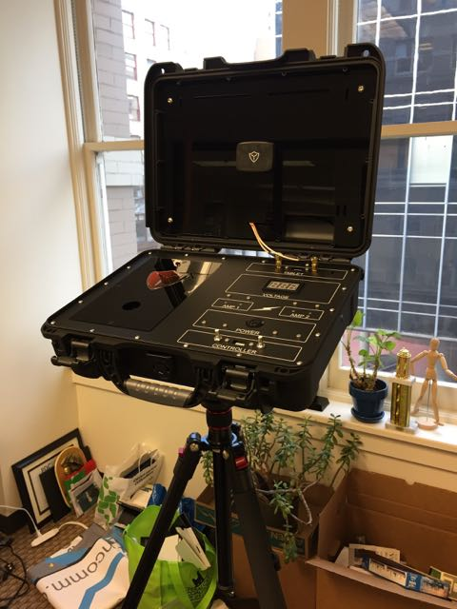
Flying in the Portland metro and other urban areas requires experience and skill to operate UAVs in congested urban environments with buildings, power lines and other obstacles, including significant potential for signal and magnetic interference from structures and electronic interference. In these environments ATC uses range extenders on all controllers as well as the Titan Command Case, which is a sophisticated portable range extender and signal booster. Among other projects, ATC's experience in operating drones in urban areas includes the Karl Miller Center grand opening at Portland State; the El Grito Celebration at the Moda Center; shooting construction projects for the Northwest Examiner such as Centennial Mills; the aerial videography and photography for the Broadway Corridor Planning Project; the Clinton Triangle; and others. We also have extensive experience flying in the urban centers of Panama City, Panamá and Accra and Tema, Ghana.

ATC also uses a wide range of Intelligent Flight Modes to achieve the desired results for clients, including:
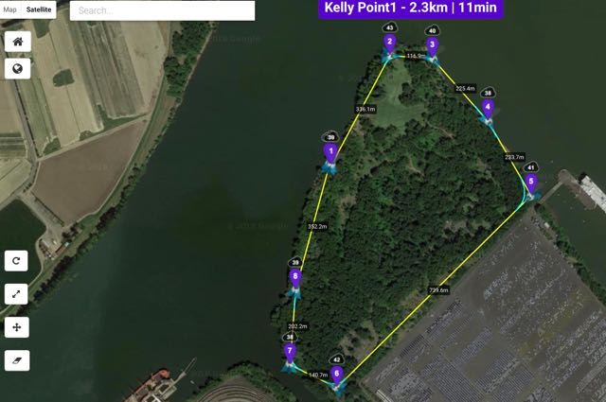
- Active Track
- Tripod Mode
- Trace (Follow behind, in front or circle a subject)
- Profile (Fly alongside a person or object)
- Spotlight (Keep the camera on an object while you fly)
- Point of Interest (drone flies in a preprogrammed radius)

Kelly Point Park

ATC uses the most sophisticated mission planning software in the world for our projects. The Litchi program allows us to create and fly from waypoint to waypoint at specified altitudes, speeds, and distances and camera angles, which provides superior images and greater safety.

Videography

Cameras and related technology change as rapidly in this business as the software. At ATC we stay on top of all the latest data regarding aircraft, cameras, capabilities and the bugs that new releases bring with them by analyzing and testing prior to purchase and deployment. We have also developed customized settings for each of our aircraft and cameras for each of the major social media platforms, including optimized settings for shutter speed, exposure, white balance, in flight stabilization, ISO, aperture and metering.

Drones and Cameras
The DJI S1000 is one of the largest and heaviest available and is used to carry a DSLR camera such as Lumix GH4 or Canon 5D Mark II. It is extremely steady in windy environments and best used for high end cinematographic footage.
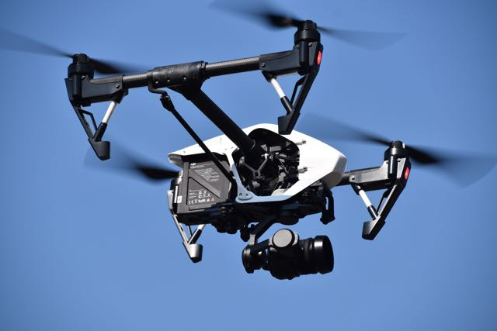
The Inspire 1 Pro is also another extremely high quality UAV/drone, and we use two cameras with this one. Both have 12MP stills and 4K or 1080p HD video. The X5, which is larger, uses interchangeable micro 4/3rd lenses. At ATC we typically use the Olympus Zuiko 12mm, 12-42mm, 45mm and 40-150mm lenses as well as the DJI 15mm.

The Phantom 4 Pro shoots 4K/1080p HD video and 20 mp stills with its one-inch lens and mechanical shutter. It is excellent in all conditions but especially good for very tight flying environments because it has sonar obstacle-avoidance. The 20MP stills, especially when shot in RAW, provide some of the sharpest resolution in the industry.

The Mavic Pro is small, fast and extremely versatile and has a flight time of nearly 28 minutes. We frequently use it as a scout aircraft to use first before flying the larger drones but it takes 4K video and 12MP stills in its own right. It is especially good for tight, precise flying environments. It is adaptable to high altitude image and data collection and also for shooting in wooded areas, along paths and in urban areas.

The Mavic Pro 2 has the same qualities as the Mavic Pro and with the added benefits of 4k stabilized video, 1” CMOS sensor, 20MP still images, and the most advanced obstacle avoidance system in the industry.

In addition to aircraft and cameras, ATC uses the DJI Virtual Reality/First Person View goggles, which allow clients and creative directors to watch the flight and data collection as if they were sitting in the nose of the drone. We also connect the drone controllers to large external monitors on tripods so clients who want to participate in the flight operation can see exactly what shots are being obtained and can provide on site direction as needed.

Drone Shots
Unmanned Aerial Vehicles/drones have revolutionized the world of public affairs, advertising and social media. The ability to produce dramatic video and stills from all altitudes and angles provides an entirely new dimension to the world of communications products.
​
Numerous shots using UAV/drones are not available to conventional shooting – the camera can fly away from the subject point or toward it; it fly laterally at any altitude, giving you multiple options for airborne sliders; it can circle a single point, called point of interest shooting, and from any direction or altitude.

It’s not just aerial video but an entirely new range of creativity open to your team.

Good drone videography requires a combination of piloting skills and programming, top quality technology, and an in-depth knowledge of the range of shots and styles available.

The following page is a partial list of drone shots that we can use to make any video storytelling pop:

Sample Drone Shot List

Reveals
Ninja (forward+ back and up)
Leap behind (backwards+up+gimbal up)
Swan dive (forward+down+gimbal up)
Back drop (back+down+gimbal up)
Reveal low and high (straight down)

Taking Flight
Take off (forward+up+yaw left/right)
Landing (forward+down)

Pull Back
Look up (forward/back+gimbal up)
Pull back POI (high shot, point of interest)
Slant pull back (straight back+left/right)

Low Flight
Sprint (straight+forward)
Low flight (forward+yaw left/right)
Sky (forward+gimbal up)
Simulate walk (hold drone by hand)

Pass
Fly over (forward+gimbal down)
Strafe pass (left/right)
Pitch up (forward+up+gimbal down)
Diagonal (forward/back+left/right)
Lift pass (strafe up+left/right)

Heads Up
Heads up (forward+gimbal rise)
reverse heads-up (back+gimbal up)
Fifty-fifty (forward+gimbal up for
shorelines, rivers, train tracks)

Crane
Crane up (rise+gimbal down)
Slant (rise+left/right+gimbal down)
Crane down (descent+gimbal up)
Way up there (strafe up+gimbal up)
Ground shot (strafe down+gimbal down)

Dual
Side strafe (lef/right+yaw left/right)
Sky shot (gimbal down+strafe down)

Top Down
Lift off (strafe up+gimbal down 90°)
Top down pass (Strafe left/right+gimbal
down)
Winding up (rise+left/right+gimbal 90°)
Winding down (descent+left/right+gimbal
90°)
Diagonal down (up/down+left/right+gimbal
90°)

Angle
Angle up (forward+up)
Reverse angle up ((back+up)
Angle down (forward+down)
Reverse angle down (back+down)

Strafe
Strafe lift (left/right+rise)
Strafe yaw (left/right+yaw left/right)
Strafe gimbal (left/right+gimbal up/down)
Dolly (strafe left/right)

Tripod
Stasis (yaw left/right+gimbal down)
Sky sweep (strafe left/right as high as
possible)
To horizon (yaw left/right+gimbal up)

Yaw/Pan
Ascend yaw (up+yaw left/right+gimbal
down)
Descend yaw (descent+yaw left/right

