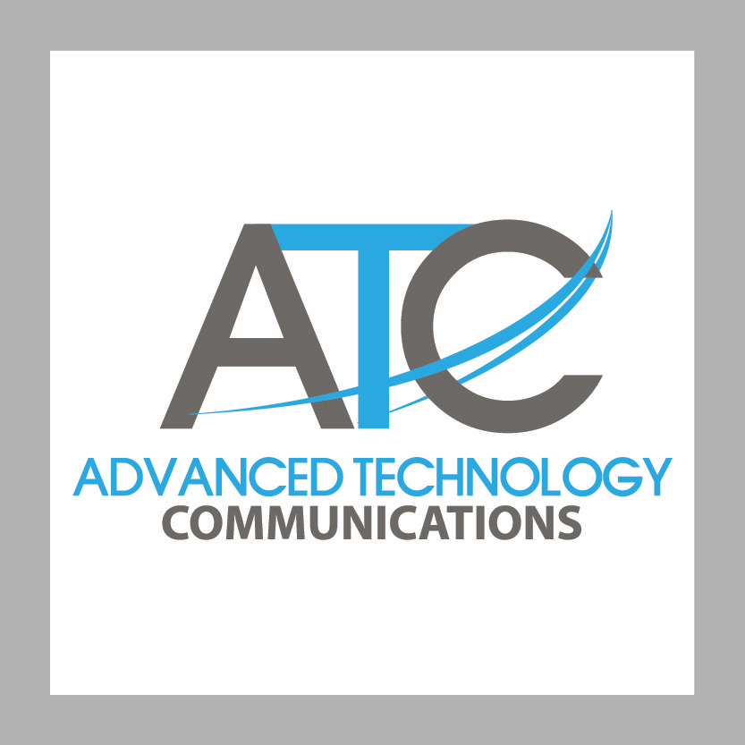

FOR IMMEDIATE RELEASE CONTACT: JOHN JACKLEY
August 4, 2017 +1-506-706-4204
JohnJ@advancedtechcomm.com
www.advancedtechcomm.com

GPHA Drone Program To Dramatically Improve Emergency Response at Tema and Takoradi;
Caution Expressed About Further Delay

Accra – Two recent emergencies – the fuel tanker explosion on May 10 at Takoradi with over 100 injuries and the injuries at the strike at Tema on June 22 – have underscored the urgency of using advanced technology to improve crisis response and emergency management to disasters. Fortunately, the upcoming Ghana Ports and Harbours Authority drone project to create and deploy an unmanned aerial system at the ports of Tema and Takoradi will provide this badly-needed high technology that will save costs, increase efficiency and dramatically improve the GPHA’s ability to manage emergencies on land or at sea.

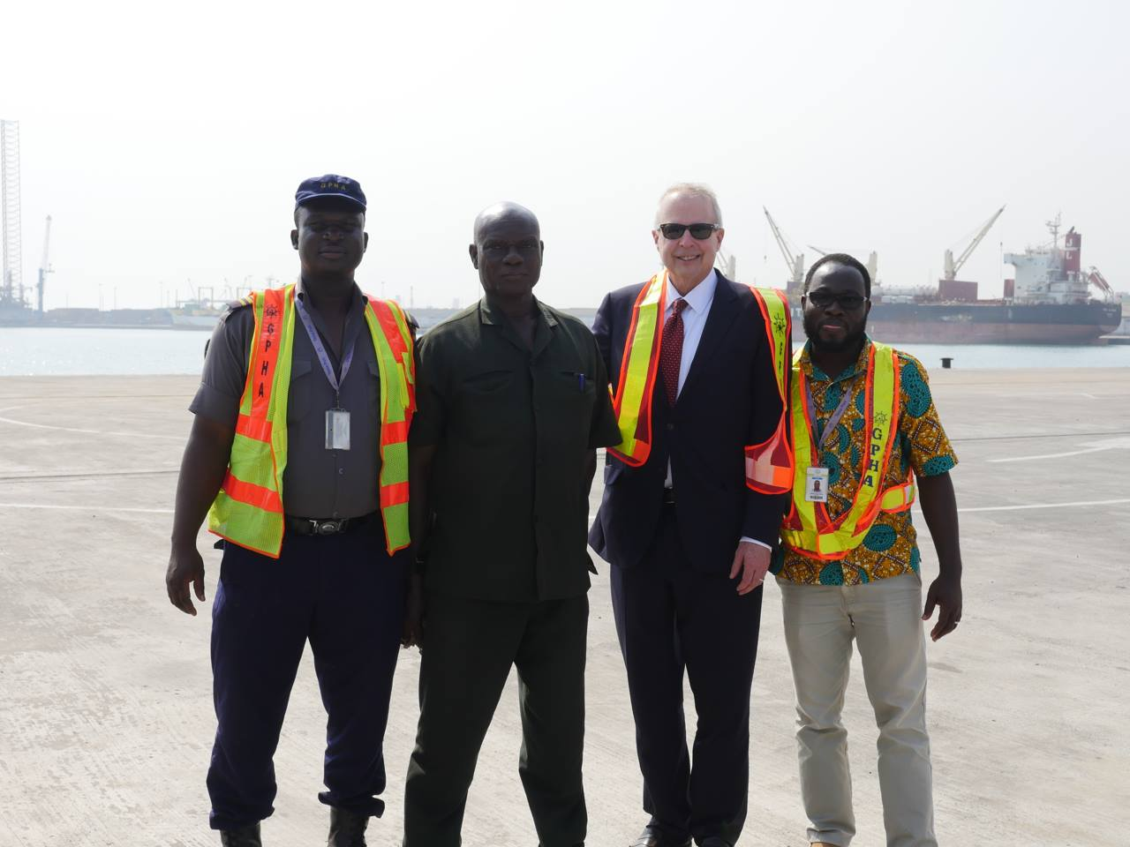
“When the GPHA unmanned aerial system is deployed later this year, the ports will have a state of the art capability to assess and manage any emergency in or around the port areas,” said John Jackley, the CEO of Advanced Technology Communications and Chiriqui Holdings International, which are designing the unmanned aerial system and conducting the training of GPHA personnel. “The response time will be immediate and in real time, day or night, and the drone system will transmit real time video and other data to decision-makers at GPHA Mr. Jackley at Tema (January 2017)
headquarters and the Ministry of Transportation,
depending on the severity of the emergency. For example, we will be able to get a drone anywhere in the port, harbour or anchorages within 90 seconds – an unheard of response time for major emergencies such the explosions at Tema, a disaster in the harbour or a security incident. And with the 24 x 7 capability of the most advanced drones in the system, GPHA can have eyes on any situation instantly.”

Project Benefits

Under the signed and approved project plan, Contract GR/GPHA/GD/0134/2016, this project will create exciting new capabilities for the GPHA:

- GPHA will be able to verify a real-time inventory of vessels in the anchorage, which it is currently unable to do, and in transit entering and departing the harbour.
- Every part of the port complexes at Tema and Takoradi will be reachable for visual, thermal and infrared inspection via real-time video transmission from the drone aircraft to GPHA HQ, Port Security, or others.
- Live broadcasts of the drone video will be available to any public or private channel.
- The proprietary system of flight programming will greatly accelerate the response time to any situation or emergency.
- Ghana will own the system and always retain control and security.

Project Chronology

The project was proposed to the GPHA in 2015 and approved by the Ghana Public Procurement Authority in August 2016. The contract and approved project plan were signed in September 2016 with final details wrapped up in December 2016. CEO John Jackley and COO Komi Kalevor met with GPHA staff in January 2017 to assess the initial operating environment in the port and harbours complex and to conduct technical assessments to prepare for the project implementation. GPHA staff provided detailed direction ranging from the timetable to the selection of cameras for the largest drones, and also directed that the consultant team extend the coverage period for the advance payment guarantee and the performance bond.”

“The GPHA should be congratulated for their vision because this project goes beyond an ordinary program – it provides training and knowledge transfer, and prevents 21st century technological colonialism by providing GPHA with the hardware, software and training to completely own and manage the unmanned aerial vehicle system,” Jackley said. “Ghana will keep and maintain sovereign control over the drone operations, the data and the technology. In addition, the GPHA will have trained personnel in the piloting and managing of the drones and related systems, which will increase jobs and training for the future.”

Progress To Date

The kick off meeting took place at GPHA Headquarters in Tema with the GPHA project team, senior leadership, and project consultants John Jackley and Komi Kalevor. The GPHA team received a detailed briefing on the drone system and its safeguards, and GPHA directed that the program be deployed in the summer of 2017. GPHA provided the necessary documentation for its personnel to travel to Riga, Latvia to receive training on the long-range system and the consultant team coordinated the visa requests with the Swiss Embassy in Accra.

At Tema the consultant team of John Jackley and Komi Kalevor conducted extensive technical testing regarding the operating environment in the port and harbour area, the anchorage and the territorial waters beyond. A GPHA security team accompanied them as they met with officials, workers, the head of Port security, the managers of Tema and Takoradi, and many other personnel. The Phase One initial report was provided to the IT and GPHA engineering staff in January 2017.

System Components

The GPHA Unmanned Aerial System has three main components – 1) selection and procurement of advanced drones to use in and around the port and harbour complexes for maritime security, shipping traffic control, security and construction inspection/documentation; 2) the long-range drone system Penguin C built in the Republic of Latvia for maritime security and anti-piracy operations up to 100 km in the Gulf of Guinea; 3) related software and drone management systems; and 4) comprehensive training in all of the drone aircraft and systems.
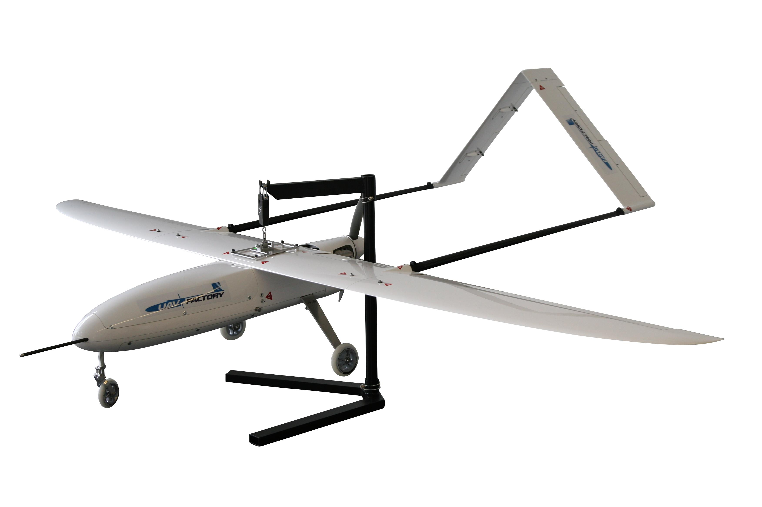
The Penguin C has a range of 100 km and stays aloft for 24+ hours

The training for the port and harbour unmanned aerial systems will take place at the Port of Tema. GPHA personnel will travel to Riga, Latvia for training in the long-range system.

All contract payments and project completion are bonded and insured through GLICO Ltd. in Tema, which means there is zero risk to the government and taxpayers. The principal
project consultants are Chief Executive Officer John Jackley of Portland, Oregon USA and Panama City, Panama; and Chief Operating Officer Komi Kalevor, of Vancouver, Washington USA and Accra, Ghana. Together they have supervised over $1 billion in public construction projects in the state of Oregon in the last fifteen years prior to the founding of Advanced Technology Communications in 2015.

Dangers of Delay

Given the emergencies over just the last two months, COO Komi Kalevor cautioned against additional delays in the project. “This project is one of the most cost-effective projects ever,” he pointed out. “And ultimately it’s not about the technology – it’s about the safety, technology transfer and economic development to benefit the people of Ghana. This project is the opposite of most – it prevents another 21st century technological colonialism by transferring knowledge, expertise and experience directly to Ghana. Our country will maintain sovereign control over the systems, the data and any future improvements. We have the opportunity to lead not just the subregion but the entire continent in the development and application of this technology to increase economic development and security, and it’s time to move forward as soon as possible. We can’t afford the next emergency without the most advanced tools to deal with it.”

For additional information, please contact CEO John Jackley at +1-506-706-4204 or JohnJ@advancedtechcomm.com.

- END -

